# Chapter 6: Neutral and Positive Messages

## LO1 Creating a Positive Work Environment

Writing positive messages contributes to developing positive working relationships and creating a culture where people feel as though they belong. Most people love getting compliments and thank-you notes. Research shows that people underestimate how surprised and happy someone will be to receive a genuine note of appreciation.

Instead, they worry that their message will be awkward. Managing our self-doubt to write a note simply out of a sense of gratitude is an important aspect of character. Can you be grateful without expecting something in return? The good news is that you likely will feel better. When people practice gratitude, they experience benefits to their own well-being.

In this chapter, you learn how to write positive and neutral messages, which are probably the most common type of business writing.

### Appreciation at Work

We need more positivity at work. A LinkedIn poll found that 80% of professionals experience the “Sunday Scaries”, that post-weekend, pre-work anxiety that one employee calls “low-grade, existential dread.” **Employee engagement, which refers to a culture where employees feel “involved in, enthusiastic about, and committed to their work and workplace,**” has been miserable for many years.

An annual Gallup survey found only 15% of employees worldwide and 35% of employees in the United States actively engaged and 14% in the United States feeling disengaged. Although engagement has been inching up, the numbers show that employees need to feel acknowledged for who they are and recognized for what they do.

In her commencement speech at Harvard University, talk show host, producer, and author Oprah Winfrey described the importance of appreciation and validation (Figure 1).13

*I have to say that the single most important lesson I learned in 25 years talking every single day to people was that there’s a common denominator in our human experience…. The common denominator that I found in every single interview is we want to be validated. We want to be understood. I’ve done over 35,000 interviews in my career. And as soon as that camera shuts off, everyone always turns to me and inevitably, in their own way, asks this question: “Was that OK?” I heard it from President Bush. I heard it from President Obama. I’ve heard it from heroes and from housewives. I’ve heard it from victims and perpetrators of crimes. I even heard it from Beyoncé in all of her Beyoncé-ness. She finishes performing, hands me the microphone, and says [Oprah whispers], “Was that OK?”… [We] all want to know one thing: “Was that OK?” “Did you hear me?” “Do you see me?” “Did what I say mean anything to you?”*

Employee recognition increases job satisfaction, motivation, and feelings of competency. At work, we tend to take good work for granted and give feedback only when we notice problems. In one study, more than 25% of employees said they considered changing jobs because of “lack of recognition for their efforts.” Hearing only complaints can be demoralizing and might discourage people from making any changes at all.

### Types of Positive and Neutral Messages

Positive messages may travel within or outside an organization. Internally, a manager recognizes an employee’s contribution to a project, a coworker congratulates another on the birth of a child, or an employee thanks a manager for constructive feedback. Externally, a customer thanks a sales associate in a store or writes a positive review online.

## 6-2 Writing Neutral Messages

Typically, neutral messages are shorter and more direct than persuasive and bad-news messages. Your audience will likely be interested in what you have to say, so a quick audience analysis may be all you need. Then you can begin drafting your message, starting with the main idea, followed by explanations and details, and then a friendly closing.

### Start with the Main Point

When writing a positive or neutral message, put your main point up front. When requesting information—a neutral, routine message—ask for what you need clearly and directly in the first sentence or two. You may use a question, a statement, or a polite request, which asks the reader to act rather than actually giving a yes-or-no answer. At times, you might find it awkward to ask for information or help. The examples might make it easier for you to start your message. Examples of request:

1. Direct Question: When do you expect the Ray-Ban Sunmasters to be back in stock?
2. Statement: Please let me know when you’re available to meet about the donation.
3. Polite Request: Would you mind telling me how you arranged for summer housing in Dallas?

* Remember that you are imposing on the goodwill of the reader.
* Ask as few questions as possible—and never ask for information that you can easily get on your own.
* If many questions *are* necessary, number them in a logical sequence; most readers will answer questions in order and will be less likely to skip one unintentionally.
* Yes-or-no questions or short-answer questions are easy for the reader to answer, but when you need more information, use open-ended questions.

### Provide an Explanation and Details

Most of the time, you’ll need to explain your initial request. Include background information (the reason for asking) either immediately before or after making the request. Imagine that you’re writing to a former employer or professor asking for a letter of recommendation. You might need to give some background about yourself to jog the reader’s memory. Put yourself in the reader’s position. What information would you need to answer the request accurately and completely?

A reader is more likely to cooperate if you can show how responding to the request will benefit the reader. But you can skip the benefits if they feel contrived, or when they’re obvious. An email asking employees to recycle their paper would probably not need to discuss the value of recycling, which most people already know.

### End on a Positive Note

1. Use a friendly, positive tone in your last paragraph.
2. In your closing, express appreciation for the assistance, state and justify any deadlines, or offer to reciprocate.
3. Make your closing specific to the purpose and original.

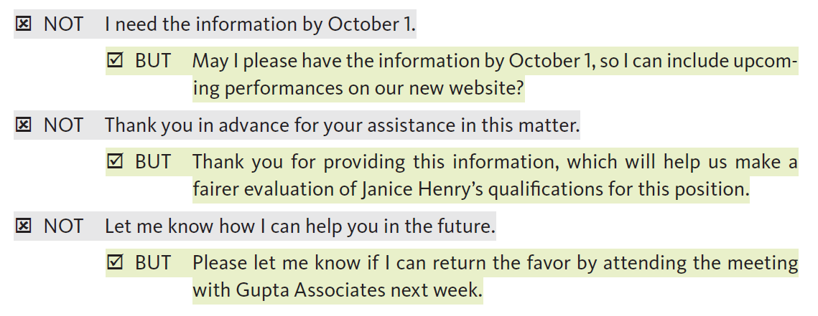

### Respond to a Neutral Message

When you receive a request, follow these guidelines:

**Respond promptly.** You’ll want prospective customers to receive your information before they make a purchase decision—possibly from a competitor. Research shows that customers will wait up to 24 hours for an email response but want it sooner. One study found that one-third of customers want a response within an hour.

**Respond courteously.** Your response represents the organization or department. A reply that sounds terse or burdened misses an opportunity to build goodwill.

* ☒ NOT: Although Aetna usually provides that type of information, I can give it to you this one time.
* ☑ BUT: Here is the information. In the future, you may contact Aetna directly at . . .

**Put your main point up front.** Make it easy for the reader to understand your response by putting the “good news”—the fact that you’re responding favorably—up front. This pattern is the same as for a neutral request.

* ☒ NOT I saw your email last week about speaking at the meeting.
* ☑ BUT I would be glad to speak at your Engineering Society meeting on August 8. Thank you for thinking of me.

**Personalize your response.** Even if you start with a template, include your reader’s name and tailor the message to specific requests.

**Promote your company, products, or services**—within reason. You may choose a subtle sales approach when responding to simple requests.

**Close your response on a positive, friendly note.** Avoid such clichés as, “If you have additional questions, please don’t hesitate to let me know.” Use original wording, personalized for the reader.

## 6-3 Writing Goodwill Messages

People send positive or goodwill messages out of a sense of kindness and to maintain or build relationships. With no true business objective, these messages convey congratulations, appreciation, or sympathy. Goodwill messages achieve their objective precisely because they have no ulterior motive. Even subtle sales promotion would make receivers suspect the sincerity of your message.

In this section, you learn guidelines for writing goodwill messages and then considerations for different purposes: recognition, congratulations, appreciation, and sympathy.

### 6-3a Guidelines for Goodwill Messages

You may send a goodwill message by texting or calling instead of writing—especially for minor occasions. People appreciate these timely acknowledgments. But an email or a handwritten note can feel more thoughtful and permanent, particularly because they require extra effort and people receive fewer of them.

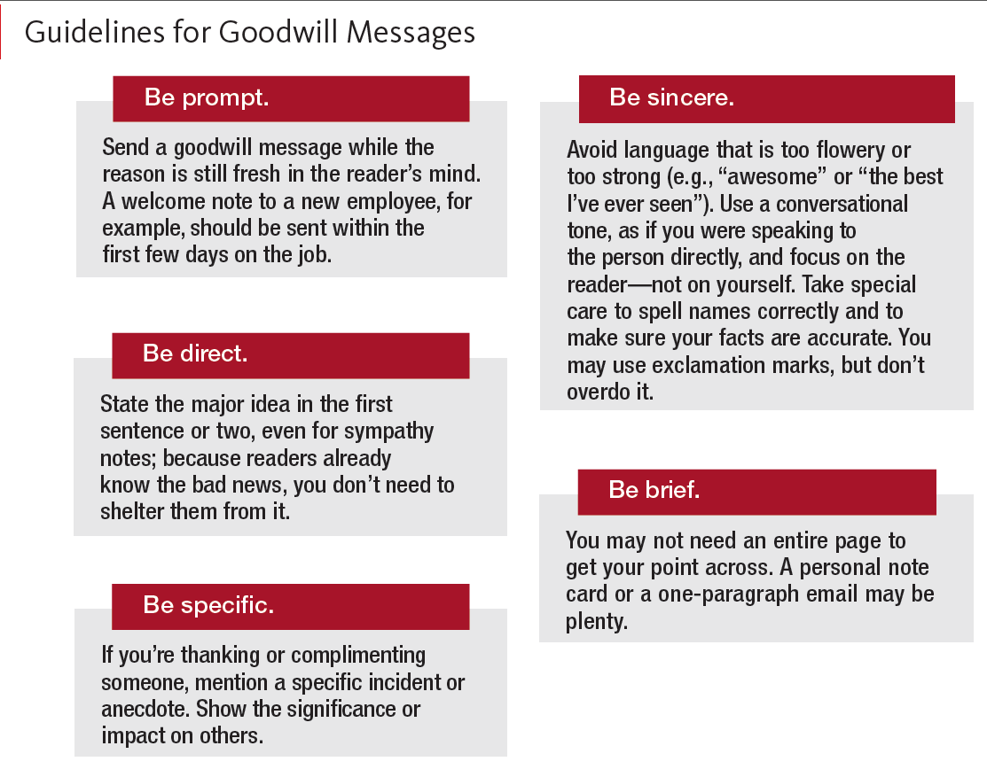

Goodwill messages vary by culture. What may be appropriate, even expected, in one country may be improper in another. Also, what is emphasized in a goodwill message may differ by culture. In a study comparing Chinese and American graduation cards, Chinese messages reflected far more “process-focused themes” of hard work and continuous self-improvement, whereas American cards emphasized “person-focused themes,” such as individual traits. Do your research before writing goodwill messages to people from cultures you don’t know well.

**Recognition Notes**

Messages should be sent to recognize when someone does a particularly good job. A short note can be directed to the person and, when appropriate, an immediate supervisor. Be clear about how the work was exceptional and how it benefitted others.

**Congratulatory Notes**

Congratulatory notes are sent for major business achievements—receiving a promotion, winning new business, receiving an award, opening a new branch, or announcing a retirement. These notes are also appropriate for personal milestones—engagements, weddings, births, graduations, and other occasions.

**Thank-You Notes**

A note of thanks is almost always appreciated. Thank-you notes should be sent whenever someone does you a favor—sends you a gift, writes a recommendation letter for you, gives you a scholarship, interviews you for a job.

The Habitat for Humanity email is personalized to the donor, noting specifically how the funds were used. The executive director reinforces the organization’s mission by describing how they work in partnership with local families.

6-3e **Sympathy Notes**

Expressions of sympathy or condolence to a person who is having a difficult time personally are especially tough to write but are especially appreciated. People who have health problems, had a car accident, or didn’t get a promotion they wanted need to know that others are thinking of them and that they are not alone.

Compassion is an important dimension of character and can relieve others’ suffering. Sometimes, we resist offering compassion because we don’t notice others’ pain, know what to say, blame the person for their problems, or simply don’t take the time. Handwritten notes convey extra care in these situations.

## 6-4 Addressing Social Media Comments

So far, we discussed one-to-one requests and responses. For customers on social media platforms—review sites, blogs, and social networks—the communication opportunities are greater and the stakes higher. Companies can win customers and build a positive reputation online, but slow and poorly written responses can lose customers and damage a company’s image—with potentially millions of people watching.

### Deciding Whether to Respond

Smart companies practice social listening. They monitor the constant stream of social media posts to learn what people are saying about their brand, products, and services. After they find these mentions of their company, social media managers decide whether and how to respond to online content. For large companies that can afford them, aggregators scan the web for comments about the company. These programs automatically collect and analyze the online messages. Smaller companies have staff members who use tools such as Google Alerts to search the web for mentions.

The flowchart shown in Figure 13, typical for organizations that pay attention to online customer feedback, helps guide a company’s response. Companies won’t necessarily respond to every online post. One study warns of overcommenting to customer reviews. When large hotels responded to about 40% of reviews, they got the maximum positive impact on ratings and revenue. Otherwise, posting too many management responses could turn off customers.

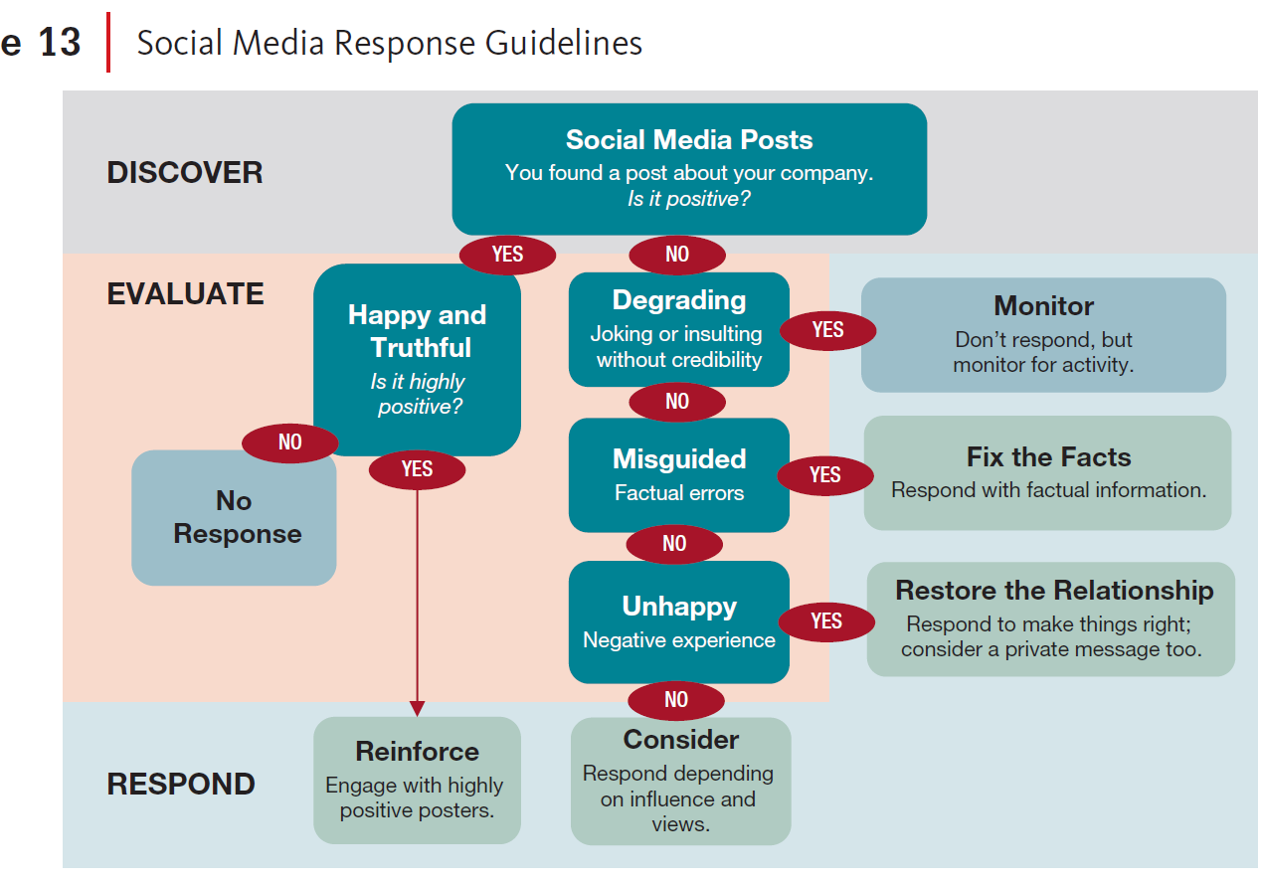

For “happy” customers whose posts are positive and truthful, you may or may not respond. However, if a post is *highly* positive, you may want to reply to engage the sender and highlight the good feedback.

If a post is negative and degrading, just monitor it in case it goes viral, in which case you will have to respond. Otherwise, responding to an insulting troll might just inflame the situation. If posts are misguided or unhappy, you will want to respond. Let viewers read the company voice and get the facts or see how you’re fixing a negative experience.

Unhappy customers may need additional communication. You might try to reach out with a private message—and let public viewers see that you’re doing so—to get more information about a negative experience and offer solutions, such as replacing a damaged item. This detail is best handled privately.

For neutral comments, for example, the Yelp post in Figure 14, management *could* respond but does not. The review is neither so positive that the company should draw attention to it nor so negative that the company should apologize and take action. It can stand alone.

### Responding to Positive Reviews

Yelp offers the following advice for responding to customer reviews:

* Start by thanking the reviewer for providing feedback about their experience.
* Highlight something positive they said in the review.
* Conclude by inviting them back.

Except for the last point, this advice also applies to employee reviews. The post from Glassdoor, shown in Figure 15, is highly positive and does warrant a management response to acknowledge the feedback. Particularly for a start-up like Maidbot, the leader’s voice is important for prospective employees to hear. In this example, the CEO responds personally, shows his appreciation, and highlights the work culture and team. Negative reviews require special attention.

**6-5 Engaging Customers and Employees on Social Media**

Simply responding to customers and prospective and current employees online isn’t enough. Ask social media managers in any company, and they will likely say the same thing: it’s all about the “conversation.”

Social media provides company leaders with the opportunity to engage with stakeholders directly. To build meaningful relationships online, companies are proactive, seeking out customers and finding creative ways to interact.

### Engaging Customers Online

A Gallup study found that few people are influenced by companies’ social media presence alone. Instead of chasing fans and followers, companies focus on building relationships with existing customers to convert them to brand advocates. To do this, Gallup suggests that companies be authentic, responsive, and compelling.

American Airlines prides itself on responding to tweets in a conversational way. When the company’s social media teams brainstormed words for their Twitter responses, they came up with “genuine,” “authentic,” “transparent,” “savvy,” “clear,” “professional,” and “warm”—never “scripted.”

DiGiorno Pizza used these principles in its social media campaign, #DeliverDiGiorno. During October, National Pizza Month, the company delivered a free pizza to people within a designated city who tweeted the hashtag. Happy customers tweeted with the hashtag a second time when they received their package, but there was one catch: the pizza was frozen. Still, the campaign was a good way to engage people and promote its frozen product.

**Engaging Employees Online**

Companies engage employees, in addition to customers, using social technologies. With a robust intranet site, senior-level managers can communicate with employees directly to convey one consistent brand message. Leaders who excel at internal communication are genuine, authentic, and transparent—the same qualities companies demonstrate on social media. An intranet site also is a good way to encourage employees to participate in conversations about the company—and to keep their comments internal. One popular social networking tool for employees is Yammer (owned by Microsoft). Rather than posting embarrassing information about a company on public websites, employees can give feedback about products, organizational changes, and management on an employee-only intranet site.

**6-6 Chapter Closing**

Every employee can be a leader in creating a more positive environment at work. Dairy Queen amplified a customer’s generosity and promoted a positive image of the company. By responding to and engaging stakeholders inside and outside the organization, you can contribute to a culture where people feel valued and connected to the company and to each other. Writing positive messages is a foundational skill to prepare you for more challenging situations, such as when you need to persuade others, which we discuss next.

CHAPTER SUMMARY

**LO1** Describe the value of positive messages in business.

People want to be appreciated and enjoy receiving positive messages. To counteract negative stereotypes and work stress, managers should recognize people for their work. Positive and neutral messages may be internal or external.

**LO2** Explain how to organize a neutral message.

When writing a neutral message, for example, to request action or ask a question, start with the main point, provide explanations or details, and end on a positive note. When responding to a neutral message, respond promptly and personalize your message.

**LO3** Apply guidelines for writing a goodwill message in a business situation.

Write goodwill messages to maintain or build relationships. Goodwill messages express recognition, congratulations, appreciation, or sympathy. Write promptly after an event and be direct, specific, sincere, and brief.

**LO4** Apply guidelines for responding to online feedback in a business situation.

Follow a strategy for social listening and deciding whether and how to respond to social media comments. Highly positive comments may deserve a response, while neutral comments can be left alone. Typically respond to misguided and unhappy customers but avoid overresponding and inflaming trolls.

**LO5** Explain ways to engage customers and employees on social media.

Companies that truly engage customers and employees through social media develop stronger connections with these audiences. Externally, with an authentic brand voice, companies inspire re-posts and extend their reach. Internally, companies encourage feedback and build relationships among employees.